
QUALITY ALERT

Customer: ChamClad Date: March 18, 2025
Die: 15750 Color: Any Color
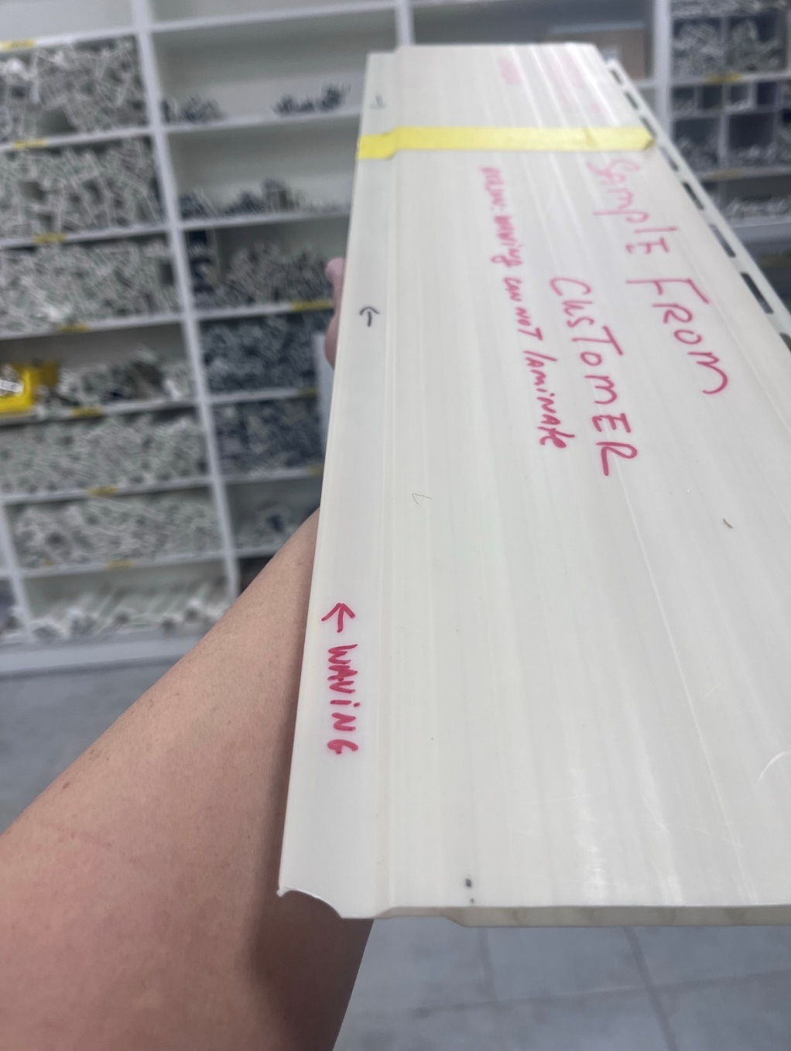
Type of Complaint: ChamClad REJECT Customer NCR:

Description: ChamClad REJECT due to waving on the hook area. Bubbles when laminate

PLEASE MAKE SURE HOOK AREA IS NOT WAVING BEFORE PACK

BY SIGNING BELOW, YOU ACKNOWLEDGE THE PROBLEM ABOVE AND AGREE TO MONITOR THIS ISSUE IN FUTURE PRODUCTION RUNS.
DAY SHIFT |  | AFTERNOON SHIFT |  | NIGHT SHIFT
NAME | SIGNATURE | NAME | SIGNATURE | NAME | SIGNATURE

